**Game Design Document**

For

**“Gem Run”**

A 2D Infinite Runner Game

Version 1.0

Nicole Silverthorn

Oct. 22 / 2013

**Table of Contents**

Game Overview..………………………………………………………………………………………………………......3

Goal/Objective………………………………………………………………………………………………...…3

Target Platform………………………………………………………………………………………………….3

Target Audience…………………………………………………………………………………………………3

Visual Style………………………………………………………………………………………………………...3

Audio…………………………………………………………………………………………………………………3

Plot and Setting…….………………………………………………………………………………………………………4

Characters, NPCs, and Obstacles………………………………………………………………………….4

Basic Level Design Concepts…………………...………………………………………………………......5

Environment Elements……..………………………………………………………………………………………......6

Core Game Play…………………………………………………………………………………………………………….6

Interface Usage.…………………………………………………………………………………………………………….7

HUD and Controls……………………………………………………………………………………………….7

Menus and General Game Usage…...……………..…………………………………………………………………8

**Game Overview**

This is an infinite or endless runner game that falls under the platformer genre. It is a side-scroller and, being avatar-based, is intended for a single-player.

**Goal/Objective**

The goal of this game is to maneuver Laila through the levels without touching or falling into anything. The only thing you want Laila to touch are the coloured gems scattered throughout each level, required to get to the next level.

**Target Platform**

The target platform is for PC’s and mobile devices, including handheld and wireless devices. And with how small this game is, could be downloaded to any console as well.

**Target Audience**

The target audience is the adolescent and teenage age groups, mainly younger females, although anyone over the age of five can play and would enjoy this simple yet addicting game. The desired ESRB rating would be E for Everyone.



**Visual Style**

This infinite runner game will be viewed from a third person perspective since it is a side-scroller. There will be 2D graphics used throughout the game.

**Audio**

This would have a very basic soundtrack on a loop for background music. As well, small sound effects for when jump is pressed and when gems are collected. Both having the option to adjust the volume levels or turn off entirely.

**Plot and Setting**

Meet Laila. Help her maneuver her way through the levels, avoiding any obstacles, bottomless pits, or quicksand, by jumping over them. She must also collect all the coloured gems in each level to advance to the next one. There will be 3 levels to start with, more to come with updates.

**Characters, NPCs, and Obstacles**



Main Character: Gems to collect

Laila



NPC#1 - *reduces health 1* NPC#2 - *reduces health 1* NPC#3 - *reduces health 1*

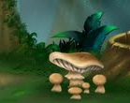

Rock Obstacle - *jump over* Mushroom Obstacle - *jump over* Deadly Nightshade - *death*



Quicksand - *death* Bottomless Pit - *death*

**Basic Level Design Concepts**

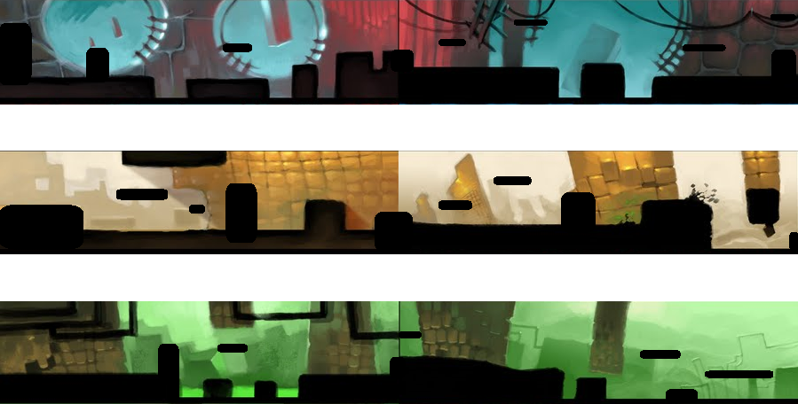

**Environment Elements**

The environments in the levels of this game include obstacles such as rocks, mushrooms, and other natural elements, like quicksand and bottomless pits. Also avoid touching the black Deadly Nightshade flower, resulting in instant death. There are also NPC’s consisting of different small creatures. There are also coloured gems scattered throughout each level randomly to be collected. The number of environment elements increases slightly throughout the levels, as well as upon choosing harder difficulties.

**Core Game Play**

After the game loads and seeing the splash screen, you continue to the main menu. If this is the first time play, choosing start/continue from here will bring you to the choose difficulty menu. If this is not first time play, upon choosing start/continue, you will be asked if you want to continue with previous game or start new game? Both choices bring you to the choose difficulty menu. After selecting the difficulty level, gameplay begins with Laila having 10 health. As she runs, jump over the obstacles, like rocks and mushrooms, and small NPC’s such as rodents and lizards. Each obstacle/NPC that Laila hits reduces her health by 1. If her health reaches 0, she dies and is returned to the main menu. Also, touching Deadly Nightshade, the black flower, results in instant death. Gems, however, Laila does want to touch and collect. There are 10 gems in the first level to collect, the number of gems increasing by 1 every other level. Every gem must be collected to advance to the next or Laila will be returned to the start of that level to try again. She must also be on the lookout for any bottomless pits or quicksand she must jump over or she dies and is returned to the start of that level to try again.

With each increasing difficulty level, Laila’s speed will slightly increase and there will be more obstacles and NPC’s to avoid on each level. The tempo of the music will increase as well.

Games are automatically saved upon exit, to be reloaded next play, if desired.

**Interface Usage**

**HUD and Controls**

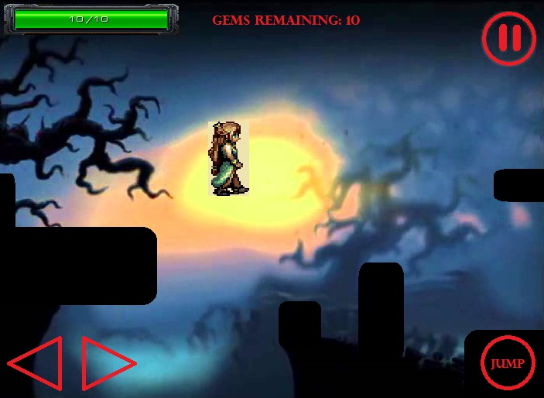

This is an example of how the HUD and controls would look on a mobile/ touchscreen device, since this would likely be the most popular platform for this game. The controls are very basic and easy to understand; left and right arrows to change direction, jump, and pause. There is also a health bar and gem count at the top right of the screen that stays the same for all platforms. For any console device, use left and right arrows/joystick to change direction, start to pause, and either X or A to jump.

There would also be basic, easy to read menus, as well as a splash screen upon loading the game, which would look something like this:

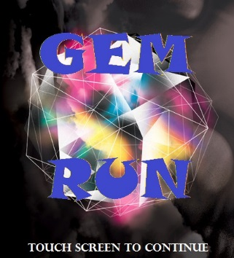

**Menus and General Game Usage**

Main Menu

- Start/Continue

- Options

- Quit

Chose Quit

Chose Start/Continue

Chose

Options

Choose Difficulty

- Easy

- Medium

- Hard

Options

Music Volume:

Off ⟵ ⟶

Sound FX Volume:

Off ⟵ ⟶

End Game

Chose Restart Level

Upon death, not collecting all gems, or completing all levels

Begin Level(s)

Pause Menu

- Resume

- Restart Level

- Quit

Game Paused

Difficulty

Chosen

Chose Quit

Menu Example:

